Quiz 1 Biology 104 Name:____________________

- Answer as clearly and concisely as you can. (Lists and bulleted points are acceptable).

- When answering, leave the questions intact and replace them _____ with your answer and use a colored font for your answers.
For example: If the question was… 1. The name of this class is _________________.
You will have… 1. The name of this class is Environmental Biology.

- Use your own words to answer the questions.
  - Answers that have been copied and pasted out of the course contents or from other sources will NOT be given credit. Quotations should not be used unless they are requested in the question.

Module 1 – Populations, Ecological Demand and Solar /Earth Capital (31 pts)

- At the end of May an ant colony on my back porch was increasing in size. There are certain changes that could explain why this was happening:
The _________ rate could be increasing due to ______________ (give one possibility)
And/or
The _________ rate could be decreasing due to ______________ (give one possibility)

Last year the same thing happened last year, but the growth of the colony stopped and there was a constant number of ants throughout the rest of the summer.
When a colony (population) stays at a constant size for a long period of time, it is possible that the _____________ ________________ of the environment was reached.

If the ant colony doubled every day and it started with two ants on May 15th and reached its maximum size on May 31st, when was the colony at half its maximum size?
___________
(6pts)

- What is the current human population size on Earth?
(2pts)

- Reading Assignment #1 “How Many People Can Our Planet Really Support?”
Link:
http://www.bbc.com/earth/story/20160311-how-many-people-can-our-planet-really-support

- Copy and paste a section from the article that was meaningful to you and explain why. (Put the copied section in quotations. A citation is not required) The points you earn here will be due to your explanation, not for which section you choose. Make sure that you put some thought into your explanation. (3pts)

If the fertility rate for the human population is less than 2.0 for the next 50 years, what will our population growth curve look? Draw the resulting growth curve below. (Use the draw feature in the Word menu). (2pts) (Note: There is more than one correct answer here.)

7.8 bill
2021 2046 2071

- An ecological footprint is a way of measuring ecological demand but what is it actually giving you an estimate of ___________________________ (2pts)

If someone’s footprint is such that if everyone lived like they did, 4.5 Earth’s would be needed to support everyone, list three things you might be able to say about that person’s lifestyle? (If you took the footprint quiz, you will know what types of things were asked about and you can use that information here to describe that person’s lifestyle). (3pts)

- Explain how the green revolution impacted water availability – be fairly specific. (2pts)

- Define each of the three categories of natural resources and give an example for each. (I gave you one category to make sure you knew what I was asking. You will need to list the other two). (4pts)

Resource category Definition Example

- Nonrenewable:

- Types of Pollutants: List 5 different types of pollution. (I’m not asking about what is polluted, so don’t put for example: “water pollution”.) (2.5 pts)

Give an example of a nonpoint source of pollution. (1.5 pts)

- Ecological services: Find a recent news article that describes an ecological service under threat. Give the title of the article and briefly explain the reason why that service is threatened. (3 pts). Here’s an example:

Ecological Service: Pollination
Article title: “Bee Reports over the Past Century Indicate a Loss of Diversity” Reasons for the threat: Changes in land use, invasive species and climate change.

DO NOT choose “pollination” as the threatened ecological service.

Ecological Service-
Article-
Reason(s) for the threat-

Module 1: Global Change Issues (33 pts)

- Observe the graph that shows atmospheric altitude and ozone concentration and then answer these questions: (5 pts)
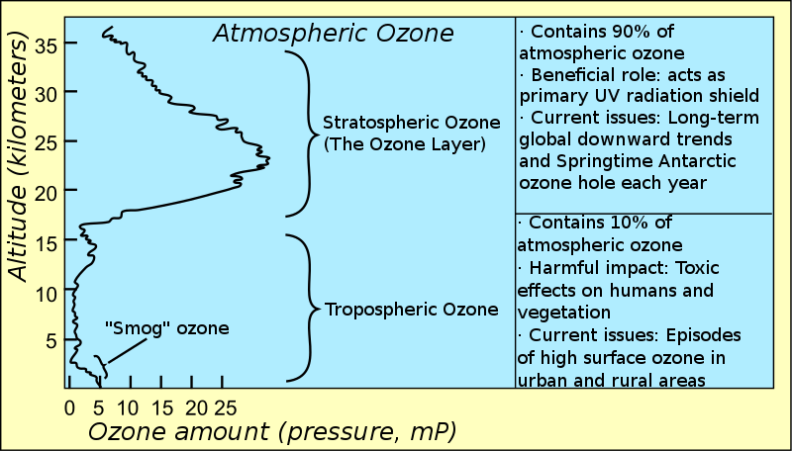

Which zone (stratosphere or troposphere) is closer to the earth's surface?

What is the relative amount of ozone in each zone?
Stratospheric-
Tropospheric -

Is stratospheric ozone considered "good" ozone or "bad" ozone?

Is tropospheric ozone considered "good" ozone or "bad" ozone?

Why is ozone good at one level and bad at the other? (explain in detail!)
Good ozone –
Bad ozone -

Which type of ozone has increased due to man's activity?

Which type of ozone has decreased due to man's activities?

- Why was the ozone “hole” smaller than it has been in a long time in October of 2019?

Why was the ozone “hole” much larger in 2020 than it was in 2019?
(4 pts)

- What does a greenhouse gas do that causes temperatures on the surface of the Earth to increase? (2pts)
In which layer of the atmosphere (stratosphere or troposphere) does the greenhouse effect take place? __________(2 pts)
The greenhouse effect is considered a ______________ (positive or negative) radiative force. (1pt)
Which of the following is NOT a greenhouse gas? H2O, N2, N2O, CH4, CFC’s.
(1pt)
List 4 serious consequences that will be seen on a “warmed” planet: (4 pts)

True or False. Climate change occurs when the Earth experiences an El Nino event. (1pt)
True or False. Greenhouse gases are found in very low concentrations (ppm or ppb) in our atmosphere. (1pt)

- Name and define three different levels at which biodiversity occurs. (6 pts)

- Explain what makes an introduced species an invasive species. (2pts)

- Find a recent “news” article (2019 -2021) about an invasive species and its impact on the new environment to which it was introduced. (The introduction doesn’t have to be recent but the article does. Stay away from informational sources and choose a news article (found in a paper or magazine, or journal) Summarize the article and provide the link to it in this answer. (4pts)

Module 2: Ecological Components & Principles (43 pts)

- Define each of the following: “population” “community” and “ecosystem” (3pts)

- List three different abiotic factors that vary between areas and are very important in determining the community that exists in particular locations on Earth. (3 pts)

- List two ways in which nutrients enter into an ecosystem.

Once nutrients are in an ecosystem how are they retained?

List two ways in which nutrients leave an ecosystem.
(5pts)

- Discuss the impacts that precipitation and temperature regimes have on nutrient availability to producers within ecosystems. (I’m expecting you to consider high & low precipitation and high & low temperatures.)

(4 pts)

- Organisms and their “roles” in their community:
Define and give an example of each that would be found an ocean environment.
Designate which of the below are the “producers” of the community by putting a P by its name (4 pts)

Autotrophs

Heterotrophs

Saprophytes

- Explain how competition impacts both species that are competing with each other. Use the symbols (+, - , 0) given in the Module content and describe why competition impacts the species in this way. (3 pts)
Species 1 ( )
Species 2 ( )
Why?

Invasive species negatively impact native species mostly by way of two types of interactions. Which interactions are those? (2pts)

- Reintroduction of top predators into ecosystems. (2 pts)

What are at least two reasons for doing so?

Why do some people think this should not be done?

(Note: You may give general answers or you can give specifics that you know from the information given about the reintroduction of wolves into Yellowstone National Park.).

- Why are organisms found where they are? (The module gave 3 reasons; please list those three here) (3pts)

- Define Keystone species:

When Keystone species are removed from their communities, biodiversity declines by more than one species. Explain why. (2 pts)

- Acclimation (acclimate) and adaptation (adapt). (3pts)

An individual organism can ____________ but it can’t _______________

Species differ in their ability to acclimate to environmental change.

Which is more likely to have a higher ability to acclimate? ____________ a generalist or a specialist (choose one)

- Does energy cycle through an ecosystem? Or does it flow through an ecosystem? - Choose one and explain the how it does so. (2 pts)

List two abiotic factors that producers need from their environment in order to be able to capture energy and turn it into biomass? (2 pts) (Don’t say sunlight… that is the energy they are capturing)

12. Carbon fixation occurs during ____________________ when sugars get built out of carbon dioxide.

Carbon dioxide is released from organic carbon molecules by two mains

processes: ______________ and __________.

[Note: one of these processes is a biological process and one of these processes is a physical process.]

Name one large reservoir of inorganic carbon. _____________________
[There is more than one right answer here.]

Explain one of man’s major impacts on the carbon cycle. _______________ [5 pts]

BONUS PLS SOLVE: 5 pts. (Note: The answer won’t be found in the Module content or Reading Assignments but it is related to Module 2 information.)
Q: What human activity (or activities) increase the risk of human exposure to both new and established zoonotic pathogens? (2 pts)

Find an article that discusses this problem, provide the link, and briefly summarize it. (3pts)

